Toilet Roll Binoculars

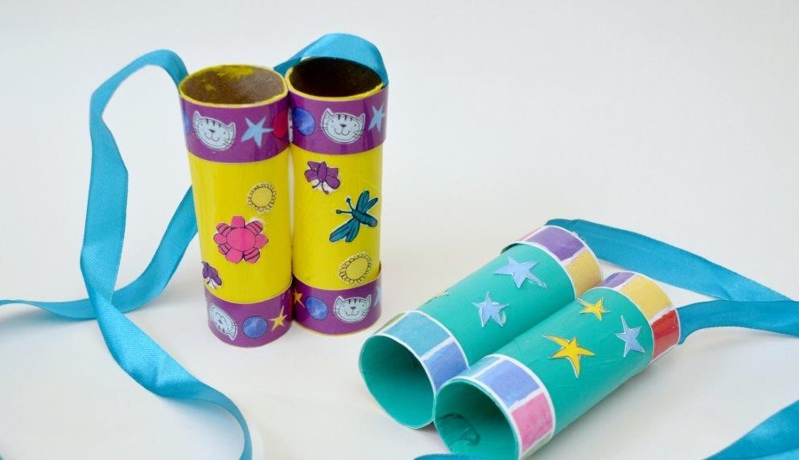

Materials:
- 2 Toilet Rolls or a Kitchen Towel Roll cut in half
- paint (or plain coloured paper)
- PVA glue
- ribbon
- decorative bits and pieces (stickers, pretty tape, poppy cat cut outs)
- clothes pegs (to help it dry

Steps:
1) Firstly choose your colours and paint your Toilet Rolls. If you don’t want to paint, you can cover your Toilet Rolls in coloured paper – a bit like wrapping a present.
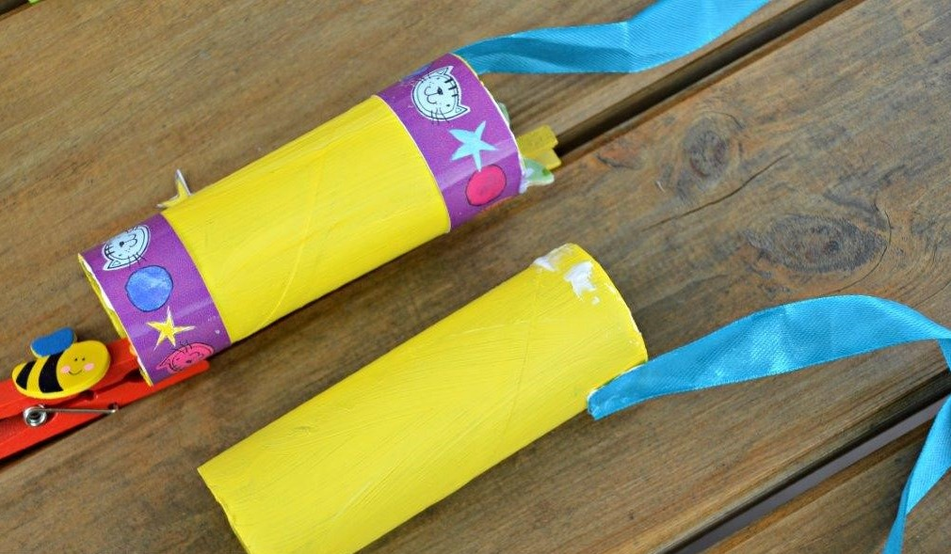
2) Once your paint is dry, glue on your ribbon (or staple it on) and then add the decorations per loo roll.
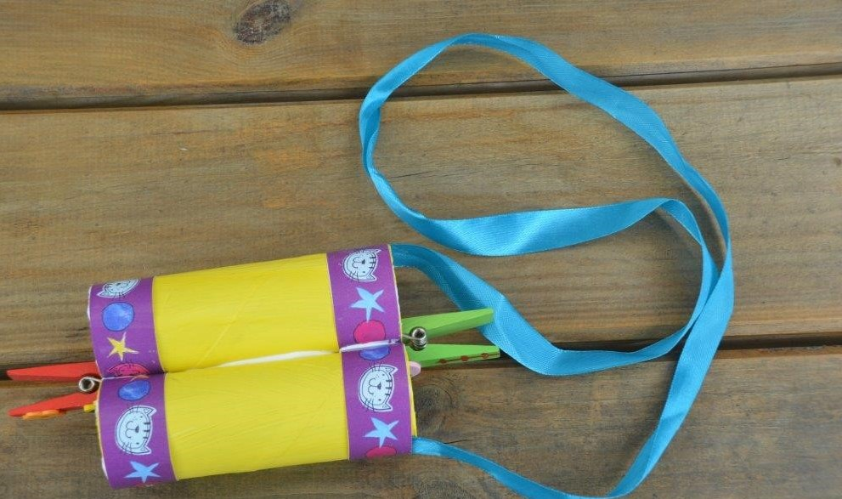
3) Glue your two rolls together – make sure that the ribbons are at opposite ends, else your binoculars won’t hang nicely. Again, you may want to use clothes pegs to hold your rolls in place whilst it dries.

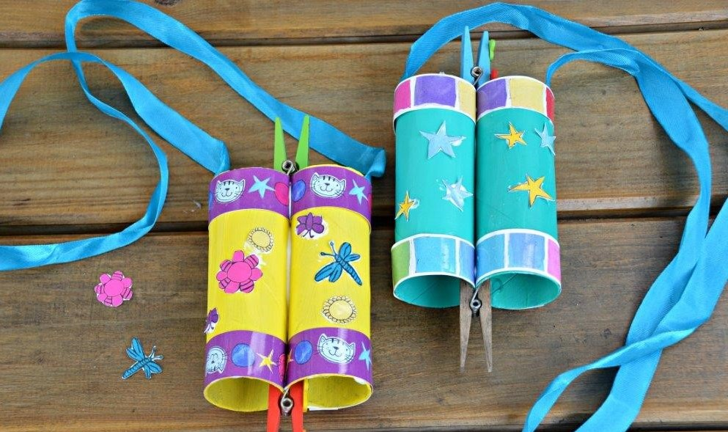
4) Add any remaining decorations and let dry!

