Pumpkin Toilet Paper Roll Lantern Craft
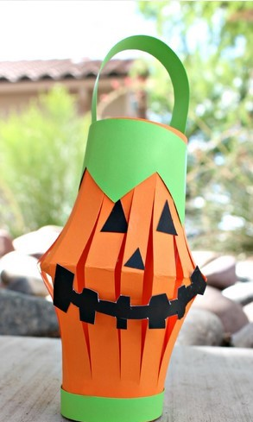
Materials Needed:
- Tape/glue
- Orange, green, and black paper
- Scissors
- Toilet paper roll

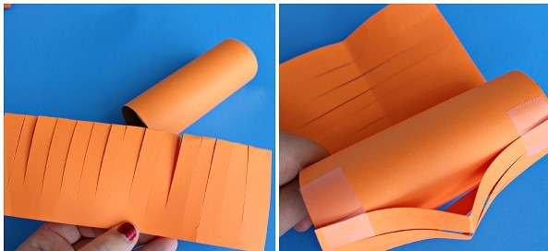
The first thing to do is wrap a toilet paper roll in orange paper then fold another sheet of paper in half and cut slits in it you can measure the height of the toilet roll first and if it a little long – you can cut it to fit. After that tape both ends to one side of the toilet roll, make sure the middle sticks out further.
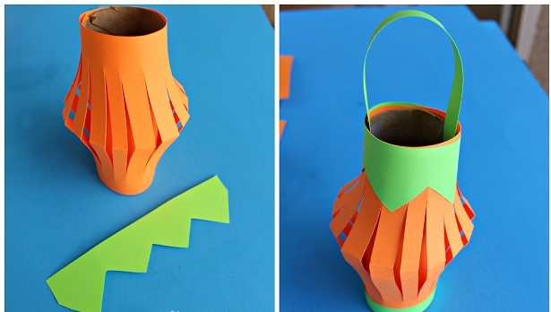
Wrap the whole thing around and tape it closed. Cut two strips out of green paper, one for the top and one for the bottom.
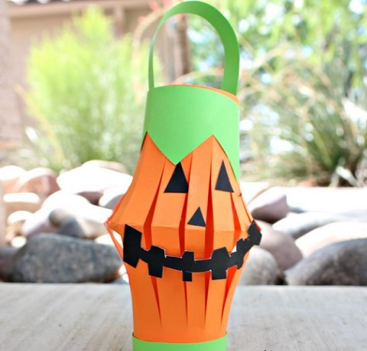
Cut out some black jack-o-lantern face pieces and glue them on! Make sure you hold them down for a while or they will fall off. Cut a skinny green strip of paper and tape it to the top inside of the toilet roll to be the lantern’s handle.

