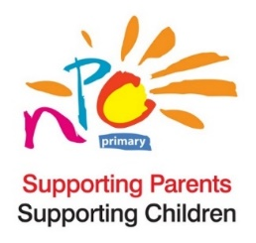

The BIG Book Review 2020

National Parents Council Primary Book Review 2020 Consent Form

Who are National Parents Council Primary (NPC)? National Parents Council Primary (NPC) is the representative organisation for parents of children in primary and early education. NPC was established in 1985, under the programme for Government, as the representative organisation for parents of children attending primary school.

Why do we need your consent? As part of the NPC Big Book Review 2020 we are asking children to send in their book reviews in whatever format they would like, they might like to draw or paint a review of the book or write a review of any length or record an audio or video clip, how they chose to review the book is their choice. NPC would like to share the book reviews we receive on our website and social media platforms. Therefore, we need a parent/guardian’s consent to share this information. We also need your child’s agreement for you to send in their review.

Details of child
Name: _______________________________________________________________________________________
Age: _______ Class: ____________________________

Details of PARENT/GUARDIAN
Name: _______________________________________________________________________________________
Relationship to child: ___________________________________________________________________________
Your email address: ______________________________ Your phone number: ___________________________

Consent by parent/guardian - Please read and tick if you are happy to do so
I give consent to National Parents Council Primary (NPC) for the following:

To share my child’s book review
To keep my child’s book review on file for the duration of the competition

I give consent to NPC to contact me in the future for the following reasons:

To forward information on NPC events
To forward links to NPC surveys/notices
To forward information relating to education
To forward information on Early Years

I give consent to NPC:
To contact me using email To contact me by phone

Parent’s/Guardian’s Signature: ……………………………………………………………… Date: …………………............................

Child’s agreement - Please ask your child to read and tick the following if they are happy to do so
I have read this form and am happy to have my book review submitted to NPC 
I am happy to have my review shared by NPC 

Child’s signature: …………………………………………………………….… Date……………………………….………

