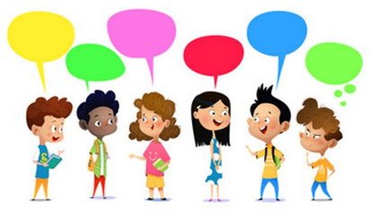
Children’s experiences of Covid-19 and their hopes for the future

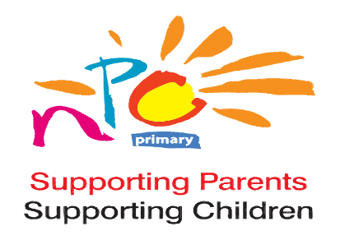

National Parents Council Primary Consent Form

Who are National Parents Council Primary (NPC)? National Parents Council Primary (NPC) is the representative organisation for parents of children in primary and early education. NPC was established in 1985, under the programme for Government, as the representative organisation for parents of children attending primary school.

Why do we need your consent? NPC would like to make a video of all of the experiences we receive and share it on our website, social media platforms and in a webinar. We need a parent/guardian’s consent to share this information. We also need your child’s agreement for you to send in their review.

Details of child
Name: _______________________________________________________________________________________
Age: _______ Class: ____________________________

Details of PARENT/GUARDIAN
Name: _______________________________________________________________________________________
Relationship to child: ___________________________________________________________________________
Your email address: ______________________________ Your phone number: ___________________________

Consent by parent/guardian - Please read and tick if you are happy to do so
I give consent to National Parents Council Primary (NPC) for the following:

To share my child’s submission
To keep my child’s submission as part of a video compilation

I give consent to NPC to contact me about my child participating in an NPC webinar event about children’s experiences of the Covid-19 pandemic and their hopes for the future

I give consent to NPC to contact me in the future for the following reasons:

To forward information on NPC events
To forward links to NPC surveys/notices
To forward information relating to education
To forward information on Early Years

I give consent to NPC:
To contact me using email To contact me by phone

Parent’s/Guardian’s Signature: ……………………………………………………………… Date: …………………............................

Child’s assent - Please ask your child to read and tick the following if they are happy to do so
I have read this form and am happy to have my hopes and experiences submitted to NPC 
I am happy to have my submission shared by NPC 
I would be happy to participate in an NPC webinar on children’s experiences and hopes

Child’s signature: …………………………………………………………….… Date……………………………….………

