Mini Yarn Hats Ornaments
If you are looking for the cutest DIY Christmas ornament ever you just have to give these mini yarn hats ornaments a go. Super easy to make and they look amazing!



What you need:
- paper rolls (toilet paper roll, kitchen paper towel rolls)
- yarn in many colours – we recommend yarn that isn’t too expensive
- scissors
- tissue paper

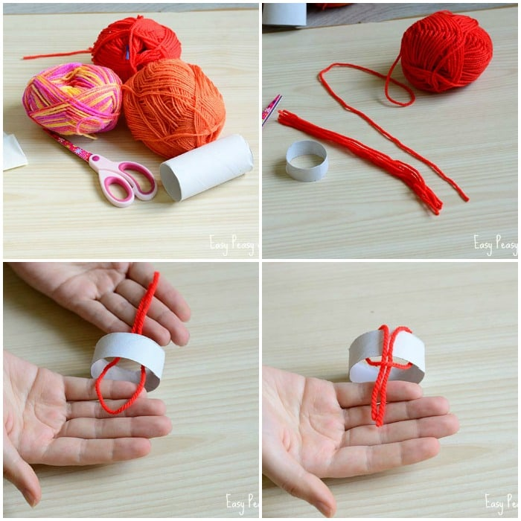

Start by cutting yarn into threads.
You’ll need plenty of threads, all with equal length, the length depends on the width of your paper roll – so you’ll have to find the perfect length for yourself.
You can start with cutting 1 thread and trying it out.
Cut the paper roll, you only need a thin “ring”.
“Fold” the yarn thread in half and push the “loop” side through the paper roll.
Now take the other end and “fold” it over the paper roll and into the loop. Pull to get a knot.

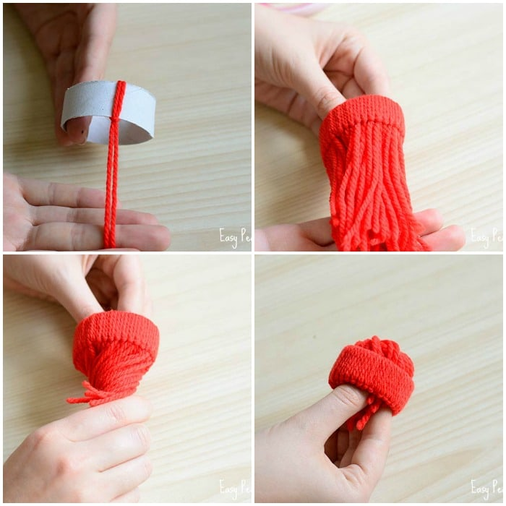

Repeat until you have all the paper roll covered with yarn.
Once all is covered you will need to push the yarn through the paper roll.
I found the easiest way to do that is to “twist” all threads and just push them through.

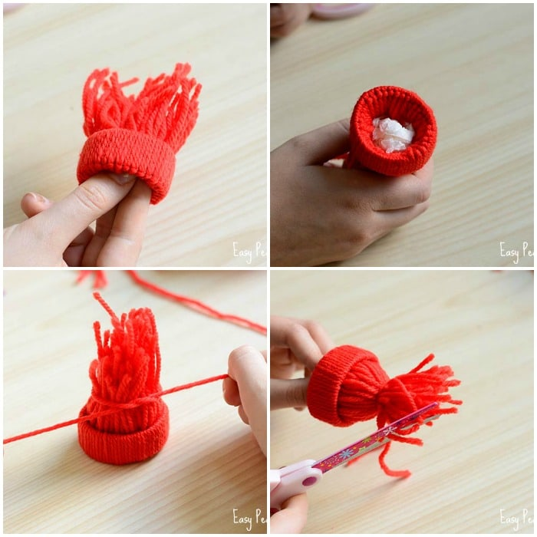

Roll a small ball out of tissue paper.
Push it into the paper roll – this will help you get the perfect hat shape and keep the yarn in place.
Now all that is left to do is to tie a knot around the threads to get a nice hat shape and trim the pom pom to get a nicer shape.

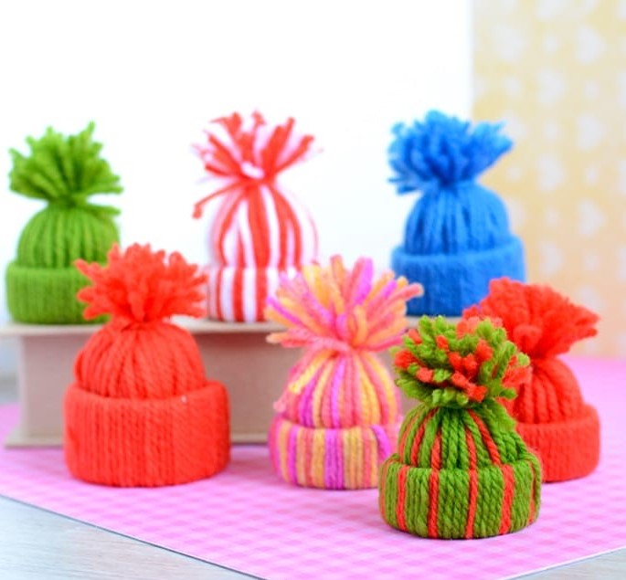

If you want to display these Mini Yarn Hats Ornaments as Christmas tree ornaments, tie some yarn under the pom pom and make a loop.



