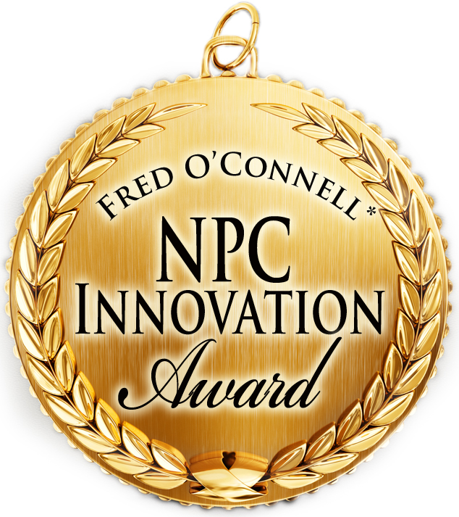

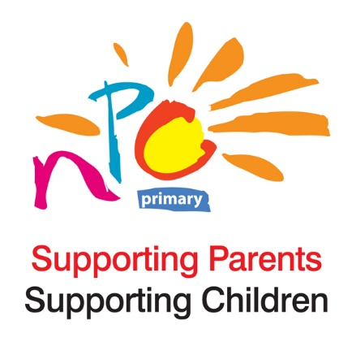

Introduction
The *Fred O’Connell NPC Innovation Award recognises NPC member parent associations who have worked towards innovative partnership between schools and parents that supports children in the last academic year.
The work conducted by the member PAs must be in line with the NPC vision where it wants to see an Ireland where every child has the opportunity to reach their full potential.

The Award
NPC has created this award to recognise member Parent Associations for their excellent work in the space of parental involvement in the school community and also to inspire other PAs to think differently and work effectively. And so to recognise the effort, NPC has three prizes for the top 3 innovative member Parent Associations and their work in the last academic year. It is as follows:
The winner will receive €500 in prize money, a plaque, engraved with the name of their Parents’ Association and the year it was won. They will also receive a free year’s membership to NPC. In addition NPC will have a larger plaque that will be presented to the winner but will be kept in the NPC office. This plaque will be engraved with the winner’s name year on year to serve as a record of all the winners of the Award.
Criteria for submitting the application
- The Parents’ Association submitting the application must be a current member of National Parents Council Primary.

- The submitted project must be an original project that has been developed by the group submitting it.

- The project must fall into the category of at least one of Dr. Joyce Epstein’s six themes of parental involvement (see page 2).

- The project must have the potential to be replicated in other schools.

Deadline for submissions
Closing date for entries is the 16th of September 2022 by 12 noon.
Entries should be marked Private and Confidential, and addressed to:
Aine Lynch, CEO, National Parents Council Primary, 12, Marlborough Court, Marlborough Street, Dublin 1, D01 XP86 or emailed to alynch@npc.ie
* Fred O’ Connell was involved with NPC in the early years of the organisation. Fred was the first paid employee of NPC. He also served as Chairperson and Vice Chairperson of NPC. He believed strongly that parents have a vital role to play in their child’s education. This award is in honour of Fred.
First developed by Joyce Epstein and collaborators in the early 1990s, the Framework of Six Types of Involvement, it is one of the most influential models in the field of school, family, and community engagement and partnership.

“The way schools care about children is reflected in the way schools care about the children’s families. If educators view children simply as students, they are likely to see the family as separate from the school. That is, the family is expected to do its job and leave the education of children to the schools. If educators view students as children, they are likely to see both the family and the community as partners with the school in children’s education and development. Partners recognize their shared interests in and responsibilities for children, and they work together to create better programs and opportunities for students.”- Dr.Joyce Epstein, “School/Family/Community Partnerships” ”

Dr. Joyce Epstein’s six themes of parental involvement, the keys to successful school, family and community partnerships:
- Parenting
Assist families in understanding child and adolescent development and in setting home conditions that support children as students at each grade level. Assist schools in understanding families.
- Communicating
Communicate with families about school programmes and student progress through effective school-to-home and home-to-school communications.
- Volunteering
Improve recruitment, training and schedules to involve families as volunteers and audiences at the school and in other locations to support students and school programmes.
- Learning at home
Involve families with their children in learning at home, including homework, other curriculum-related activities, and individual course and program decisions.
- Decision making
Include families as participants in school decisions, governance and advocacy through the PTA/PTO, school councils, committees, action teams and other parent organisations.
- Collaborating with the community
Coordinate community resources and services for students, families and the school with businesses, agencies and other groups, and provide services to the community.

Brief description of project (approximately 600-1000 words)

How does the submitted project match the following criteria?
- Originality

- In line with one or more of Epstein’s six types of parental involvement

- Its potential to be replicated in other primary schools in Ireland

Please include documentation and/or other media appropriate to illustrate the specific characteristics of the project.
Please ensure informed consent is obtained from all participants (including parental consent for under 18s) to share any photos/recordings/images making it clear these may be shared online via the NPC website. If consent is refused, NPC must be notified. Where consent is obtained it should be recorded on a consent form (please see the sample attached on page 6), dated, signed and retained by the school.

Parents’ Association Contact information
Personal data entered onto this form will be used by NPC to communicate with you. This information will only be used by NPC staff and will not be shared or disclosed to any third party. Your details will be retained for the membership year and the following calendar year. These details can be deleted from NPC files on request by you at any time; please email info@npc.ie and request that your data be removed.

Name:…………………………………………………….... Daytime Tel No. .........................................................
Email:…………………………………………………………………………………………………………
Postal address:………………………………………………………………………………………………………………………………
………………………………………………………………………………………………………………………………………………………
Do you consent to allow NPC to contact you by (please tick P the boxes)
a) Email * b) Telephone * c) Home address *
Do you consent to allow NPC to contact you for the following reasons (please tick P the boxes)
- To forward information on NPC events *
- To forward a link to NPC surveys/notices *
- To forward information relating to education *
- To forward information relating to Early Years *

Signed: …………………………………………………………….. Date:………………………………………………………..…

School name: .............................................................................................................................
School address: ..........................................................................................................................
……………………………………………………………………………………………………………………………………………….
School Roll number: .........................................

Informed consent
Informed consent is a process whereby participants are informed and asked for their permission or agreement prior to taking photographs or recording images. Individuals should be informed of:
- the purpose(s) the image will be used for, and
- the people/bodies to whom it might be transferred.
The individual should be asked for their prior written consent. Where images may be used for a variety of purposes (e.g., documenting, promoting or celebrating through press coverage, websites etc.), consent for each purpose and/or in a variety of settings (e.g. reports, public media, or websites) should be obtained on an “opt-in” basis.

SAMPLE CONSENT FORM:

We would like to take photos/digital images/recordings of your child and use them for the following purposes.
Do you give your consent as parent/guardian for the Parent Association to do each of the following:
Tick box if “yes” you agree with these uses
Use on our school website? o
Use in our school brochure and yearbook? o
Use in our yearly school report? o
Retain in our school archives? o
Use in the NPC Innovation Award project? o

We would also like to transfer photos/digital images/recordings of your child to the National Parents Council Primary for use in the NPC Innovation Award and to be shared on the NPC website www.npc.ie
Do you give your consent for us to transfer these images to National Parents Council Primary for these purposes?
Tick box if “yes” you permit this transfer
Yes, I give my consent o
Signed: _____________________ Print Name:__________________________
Date: _______________________
Parent/Guardian or Student (where over 18 years)
As a ‘child’ is anyone under the age of 18 years, consent of a parent/guardian is required.
If consent is refused, then images should not be passed on to NPC or other third parties or put to any use not agreed. Informed consent includes being given the opportunity to withdraw consent which had been previously given, if desired. Their right to withdraw any consent previously given must be free of charge, and not result in the data subject suffering any detriment.

