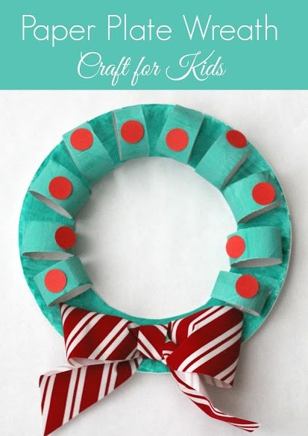
To make the wreath, we painted a paper plate and 3 cardboard rolls green and used some red stickers and a bow to finish it.
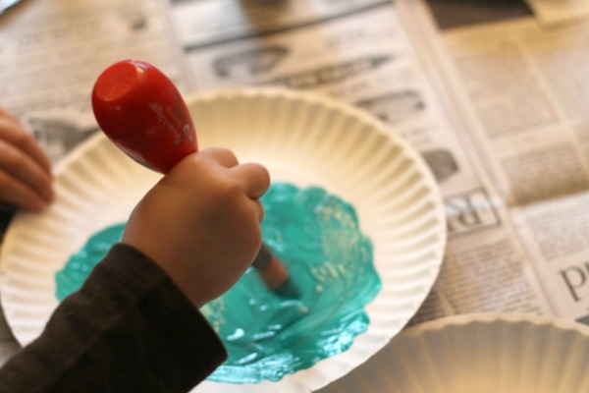
After the paper plate dried, it had warped a little, so we glued it to another plate which straightened it out a bit. I cut the centre of each plate out.
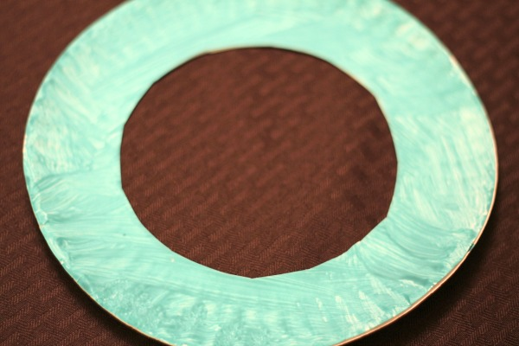

I also cut each cardboard tube into four pieces and we glued the pieces around the paper plate. I added a bow.
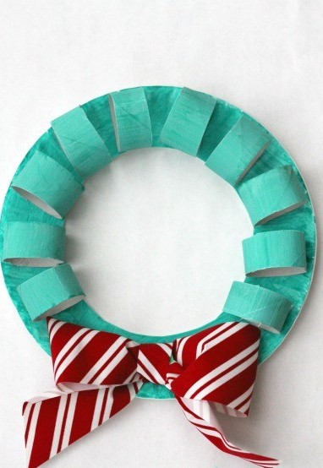
Finally, we used red stickers to decorate our wreaths.
