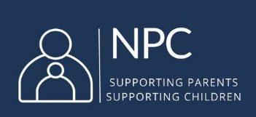
NATIONAL PARENTS COUNCIL (NPC)
CAVAN & MONAGHAN EDUCATION & TRAINING BOARD (CMETB) NOMINATION
Evidence form to support our nomination to the CMETB

Please note: at least 75% of the Parents’ Association Committee must support this nomination.
Consent is required, from the committee members approving, to share their email and/or telephone number with NPC and we will follow up with them to verify approval, to ensure fair procedure.

Name of the Nominee: ……………………………………………………………………… (please PRINT in block capitals)
To be completed by a member of the Parents’ Association Committee:
Name of the school: ………………………………………………………………………………………………………………………
Address of the school: …………………………………………………………………………………………………………………….
………………………………………………………………………………………………………………………
………………………………………………………………………………………………………………………
Roll number of the school: …………………………………. (a 5 digit number followed by a letter e.g. 12345A)
Number of parents on the Parents’ Association Committee: …………………………………….
The following members of the Parents’ Association Committee support the nomination of the above candidate to the CMETB.
Please PRINT NAMES in block capitals of the PA Committee Members supporting nomination | Contact email and/or phone number of the PA Committee Members supporting the nomination | Please tick to give NPC your consent to contact you.

Date of Nomination: ……………………………………….………

